**Simmer Design Document**

Updated as of January 13th, 2022

Simmer is a 2D cooking-focused RPG that centers around a single playable character honing their cooking skills and learning new recipes as they make their way to becoming a well-experienced chef. The player will attempt to transition between working a day job to a full-time chef by practicing in their spare time, spending what money they can for supplies, equipment and learning about new cuisines. The player will have to manage their time, prioritize different skills, and explore new recipes to make it in the culinary world.

Time and Money Management

The first major underlying mechanic will be managing time and money. Time is replenished each day and will be consumed to perform tasks such as cooking, traveling, and going to work.

**Time** - The player’s time will be displayed on the global UI at all times and will limit what the player can do in a given day. After expending all of the time in a day, the player will be forced to return home and start the next day. The player’s can choose what to do in the given amount of time each day, but has to prioritize making money to maintain rent/necessities.

Ex. Day (24 hour):

Wake Up at 8 AM

Travel to town = 30 min

Day Job = 8 hours

Go to Grocery = 1 hour

Check Farmer’s Market = 1 hour

Travel to home = 30 min

Get Home at 7 PM

Cook dish 1 = 2 hour

Cook dish 2 = 2 hour

[1 hour to spare]

Go to sleep by 12 AM

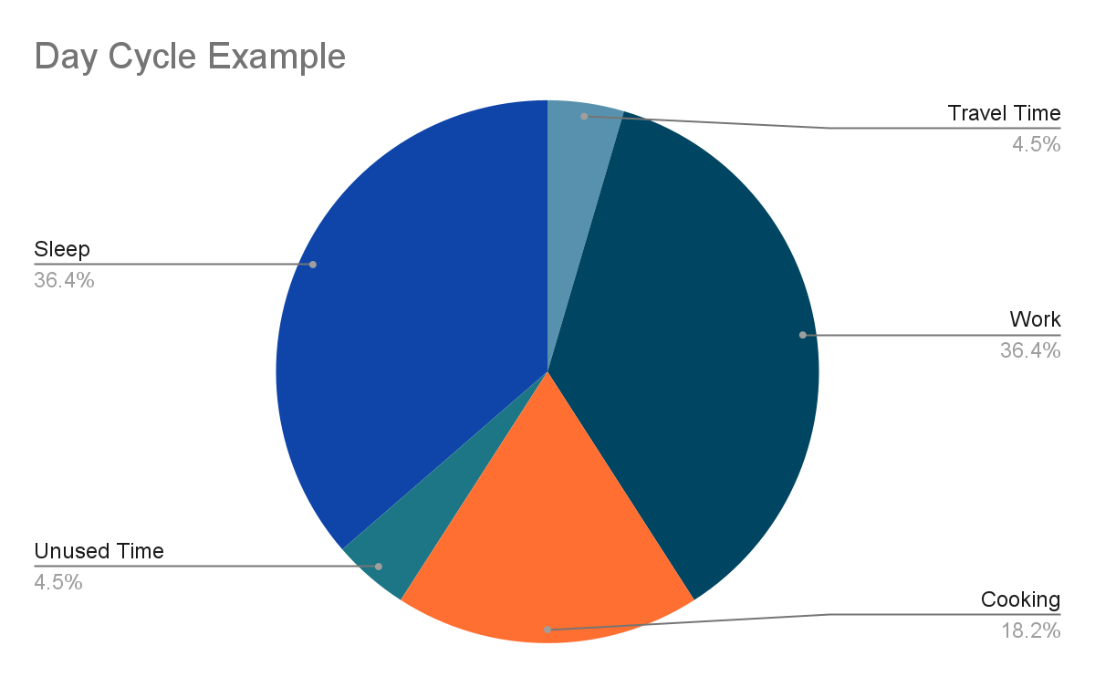

**Money** - Money can be collected by going to work, selling food items the player creates on their own, or through other methods when venturing outside the main HUB. Money can be spent on groceries, kitchen equipment, travel, as well as rent/necessities. The player will have to provide a minimum amount of money after a cycle of X amount of days for rent/necessities or there will be punishments (either loss of skill).

Cooking Technique and Skills Progression

Cooking is an experience shared across all ages and cultures. The player’s objective is to utilize their time, money, and skills to become a revered chef. Cooking will be broken down into *cooking skills*, *general food preparation knowledge*, and *ingredient identification*. Each skill will essentially apply as multipliers at each step of preparation for a given recipe and affect the final quality of the finished dish. Time will also be accounted for throughout the process and will slightly affect the quality of the final outcome, but will mainly influence how much time the player has to cook during the given day.

**Cooking Skills**

*Knife* - increases speed at which raw ingredients are chopped; affects total cooking time as well as quality of dish outcome; locks certain ways to cut vegetables, fruits and meat based on level limitation (Ex. increased knife skill allows for quality slicing of delicate items such as fish for sashimi or julienning vegetables)

*Timing* - determines how accurate the time indicator is for the player while cooking on appliances like stove, oven, and even refrigerator.

*Hand-Eye Coordination* - determines total cooking time as well as quality of dish outcomes. (Ex. folding pastries, kneading dough, arranging delicate ingredients)

**General Food Preparation Knowledge**

These attributes will be generalized to cover specific classes of recipes. The more the player cooks a certain item, the more they will master specific culinary styles.

Example: The player makes a lot of pastries which will increase their “Baking” attribute that will increase the quality of all pastry recipes the player creates.

Below shows examples for recipes that would receive multipliers based on certain recipes

| **Attributes** | Cupcakes | Cheeseburger | Beef Stew | Spring Salad |
| --- | --- | --- | --- | --- |
| Baker | x | x |  |  |
| Butcher |  | x | x |  |
| Gardner |  |  | x | x |

**Ingredient Quality Identification**

This aspect will tie more to the exploration of the environment and be a research aspect to either learn through experimentation or through other NPCs that can give the information. The information could be a strict: Good or Bad comparison of ingredients or alternatively could align with star qualities (i.e. A tomato can be rated at 1-star to 3-star but the information is locked based on whether or not you can identify “what makes a good tomato”)

Real-Time Cooking

Cooking itself will initiate when the player selects the recipe they want to begin in the kitchen HUB. To prevent the player from committing to a recipe they cannot complete, there are certain skill and ingredient checks to prevent the player from wasting time. The player then navigates the kitchen taking items and equipment to each station. Timers will be displayed over time-sensitive stations (such as a pot of soup on the stove) and the player will have to execute each step of the recipe. Checkmarks will be displayed on the recipe card after the completion of certain steps. The player will have to finish the recipe regardless of quality before they can leave the apartment. If the player ignores the recipe and does not complete it before the day is over, the player will fail the recipe and receive the lowest score. The total time of completion will be accounted for on the global time tracker.

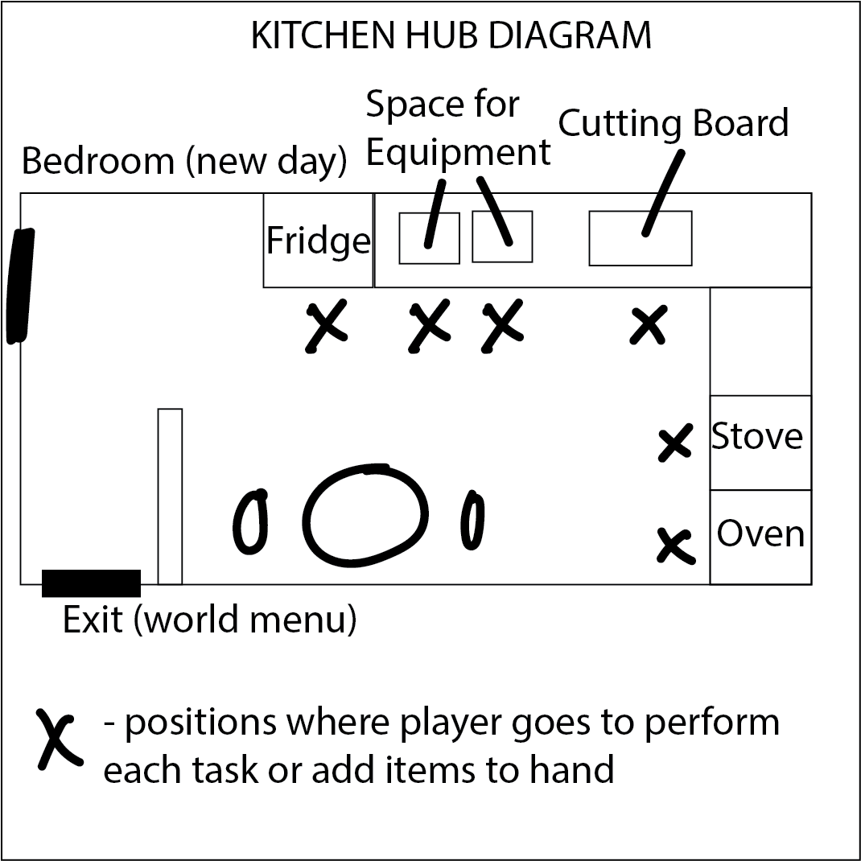

(The 3 ellipses at bottom of kitchen are just to indicate a small table and chairs)

Environment

[Warning: this segment is subject to change based on scope]

The player will maintain all of their cooking requirements (ingredients, equipment, and appliances) at home. This will be the main HUB where the player will return to cook, experiment, and improve skills. The player will be able to leave their home and travel to:

* Work (daily job, part-time job, or chef job) - to receive money after sacrificing the majority of time during the day
* Grocery Store - to select from a wide range of available ingredients, but not necessarily high quality
* Farmer’s Market - to select from a smaller range of high quality, more expensive ingredients
* Downtown Plaza - to purchase upgrades to equipment, appliances, and potentially gain new recipes
* [Reach Goal] Gathering Place - a location on the map that will include random events that provide new recipes, information on ingredient quality, or discover new cooking techniques (open to all kinds of boosts aligned with narrative goals)

Below is a simple map diagram that shows how the world is navigated. Each location would be a contained space where the player would be able to purchase goods or learn new recipes and/or skills. There would be a time cost to go and return from each location.

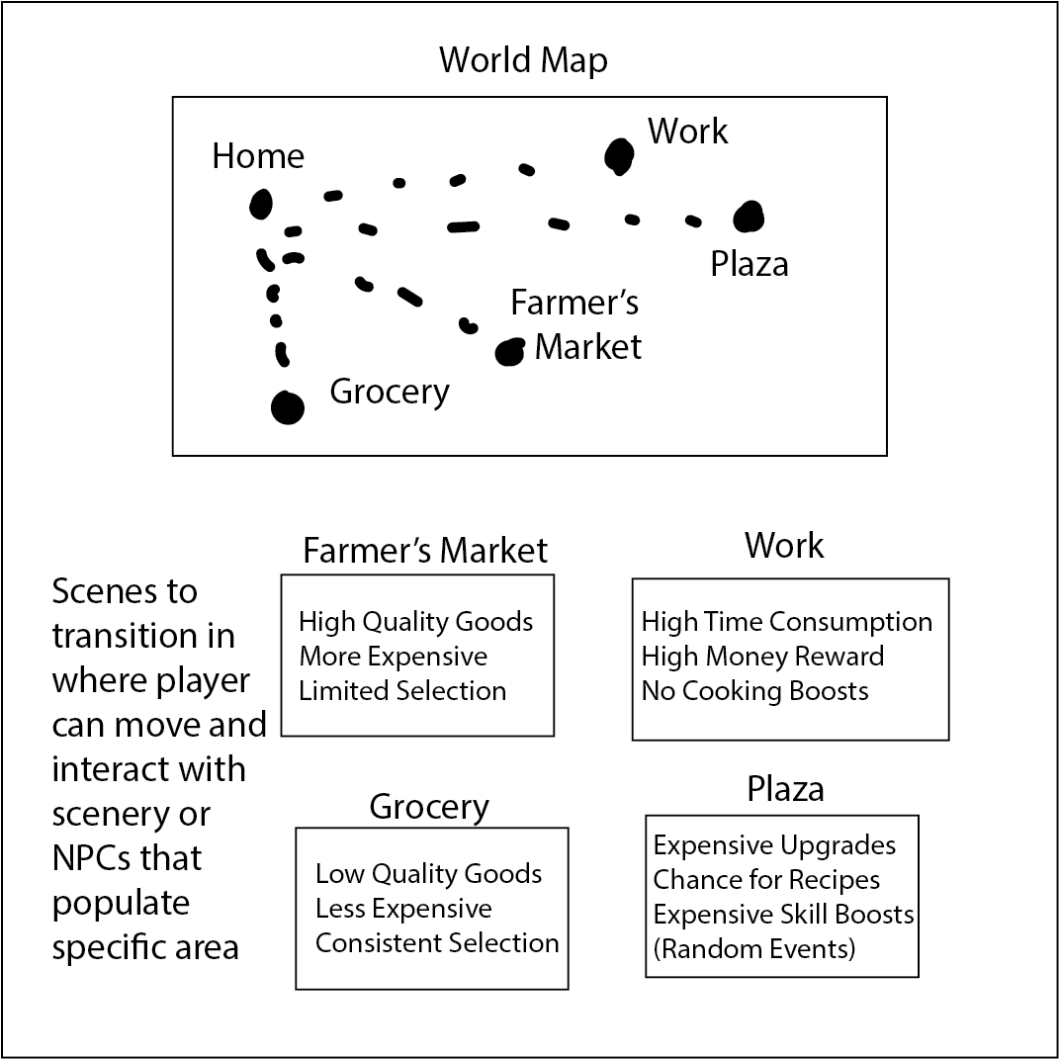

Long-Term Narrative Progression

This game’s narrative will revolve around the concept of transitioning into a different career path. First by starting out as a hobby, then slowly developing it into a full-time career of that passion.

The story can be divided into 3 stages:

1. Working a full-time job that pays well enough to keep rent and start cooking. This should be a stable career, but something the main character feels detached from. There will be a story beat that indicates the drive for the main character to cook and reach their ultimate goal of becoming a master chef.
2. The player reduces time at their original place of work and is able to make a small amount of return money from their time cooking. There would be some small narrative indications that other people (like friends and family) are maybe concerned or excited about the change in career.
3. Lastly, after meeting a certain in-game requirement, the character will be able to apply as a full-time chef at a restaurant. The player will have less time to cook at home than previously, but will be able to improve skills even further as they work as a chef.
4. [Reach Goal] Master Chef - the player has a complete knowledge of the recipes in the game, could potentially create their own recipes, and/or own the restaurant

The cooking skills and equipment will be tied to the system of the game, but there will be avenues in which the player will have to make certain life transitioning decisions, engage with other NPCs to learn, and choose what kind of cuisine they’d like to pursue. NPC dialogue should breathe life into the outside world and show a variety of people with different backgrounds and connections to cooking.